LCA 2 Experiment
Ananya Jadhav CSE A Prn no- 1262240568 rollno-62

Code-
public class lca {
public static void main(String[] args) {
Scanner scanner = new Scanner(System.in);
System.out.print("Enter employee name: ");
String name = scanner.nextLine();
System.out.print("Enter joining date (yyyy-MM-dd): ");
LocalDate joiningDate = LocalDate.parse(scanner.nextLine());
Period experience = Period.between(joiningDate, LocalDate.now());

System.out.println("\nEmployee Name: " + name);
System.out.println("Joining Date: "
+ joiningDate.format(DateTimeFormatter.ofPattern("dd-MMM-yyyy")));
System.out.println("Experience: " + experience.getYears() + " years, "
+ experience.getMonths() + " months, " + experience.getDays() + " days");
scanner.close();
}
}
o/p
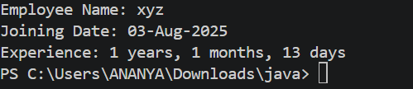

Algorithm-
- Start.
- Import LocalDate, Period, DateTimeFormatter, and Scanner.
- Create a Scanner object.
- Read the employee’s name.
- Read the joining date in yyyy-MM-dd format.
- Convert the input into a LocalDate.
- Get today’s date using LocalDate.now().
- Calculate the experience
9.Format the joining date as dd-MMM-yyyy.
10.Display the employee name, joining date, and experience in years, months, and days.
11.Close the scanner.
12.Stop

- e employee name, joining date, and experience in years, months, and days.
- Close the scanner.
- Stop.

